**Helical Antenna**

**Helix antennas** are also commonly called as **helical antennas and** have a very distinctive shape.

The most popular helical antenna (helix) is a travelling wave antenna in the shape of a corkscrew that produces radiation along the axis of the helix antenna.

These helix antennas are referred to as axial-mode helical antennas.

The benefits of this helix antenna is it has a wide bandwidth, is easily constructed, has a real input impedance, and can produce [circularly polarized](http://www.antenna-theory.com/basics/polarization.php) fields.

The basic geometry of the helix antenna shown below.

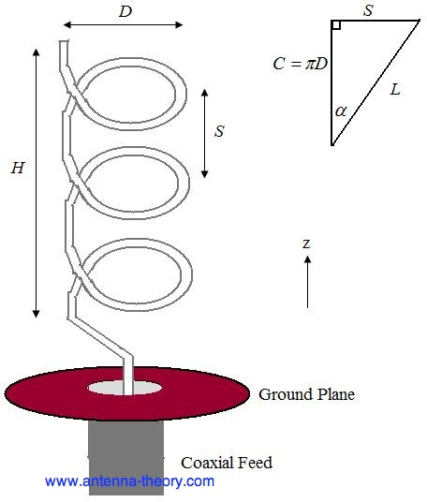

The parameters of the helix antenna are defined below.

• *D* - Diameter of a turn on the helix antenna.

• *C* - Circumference of a turn on the helix antenna (*C*=pi\**D*).

• *S* - Vertical separation between turns for helical antenna.

• alpha- pitch angle, which controls how far the helix antenna grows in the z-direction per turn, and is given by alphaEq

• *N* - Number of turns on the helix antenna.

• L - Total height of helix antenna, L=*NS*.

The antenna in the above figure is a left handed helix antenna, because if you curl your fingers on your left hand around the helix, your thumb would point up (also, the waves emitted from this helix antenna are Left Hand Circularly Polarized). If the helix antenna was wound the other way, it would be a right handed helical antenna.

The radiation pattern will be maximum in the +z direction (along the helical axis in Figure 1). The design of helical antennas is primarily based on empirical results, and the fundamental equations will be presented here.

Helix antennas of at least 3 turns will have close to circular polarization in the +z direction when the circumference *C* is close to a wavelength:

circumference of helix antenna

Once the circumference *C* is chosen, the in-equalities above roughly determine the operating bandwidth of the helix antenna. For instance, if *C*=0.5 meters, then the highest frequency of operation will be given by the smallest wavelength that fits into the above equation, or lambda=0.75*C*=0.375 meters, which corresponds to a frequency of 800 MHz. The lowest frequency of operation will be given by the largest wavelength that fits into the above equation, or lambda=1.333*C*=0.667 meters, which corresponds to a frequency of 450 MHz. Hence, the [fractional BW](http://www.antenna-theory.com/definitions/fractionalBW.php) is 56%, which is true of axial helical antennas in general. The helix antenna is a **travelling wave** antenna, which means the current travels along the antenna and the phase varies continuously. In addition, the input impedance is primarily real and can be approximated in Ohms by:

input resistance or impedance for helix antennas

The helix antenna functions well for pitch angles (pitch antenna) between 12 and 18 degrees. The optimum pitch angle is taken as 14 degrees.

The normalized radiation pattern for the E-field components are given by:

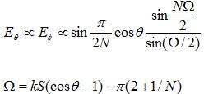

For circular polarization, the orthogonal components of the E-field must be 90 degrees out of phase. This occurs in directions near the axis (z-axis in the above Figure) of the helix. The [axial ratio](http://www.antenna-theory.com/definitions/axial.php) for helix antennas decreases as the number of loops *N* is added, and can be approximated by:

axial ratio of helix antennas

Directivity of the helix antenna can be approximated by:

$$D_{0}=\frac{{15C}^{2}NS}{λ^{3}}=\frac{15 C^{2}{NSf}^{3}}{c^{3}}$$

The gain of the helix antenna can be approximated by:

$$G=\frac{{6.2C}^{2}NS}{λ^{3}}=\frac{6.2 C^{2}{NSf}^{3}}{c^{3}}$$

In the above, *c* is the speed of light. Note that for a given helix geometry (specified in terms of *C, S, N*), the gain increases with frequency. For an *N*=10 turn helix, that has a 0.5 meter circumference as above, and a pitch angle of 13 degrees (giving *S*=0.13 meters), the gain is 8.3 (9.2 dB).

For the same example helix antenna, the pattern is shown in Figure below.

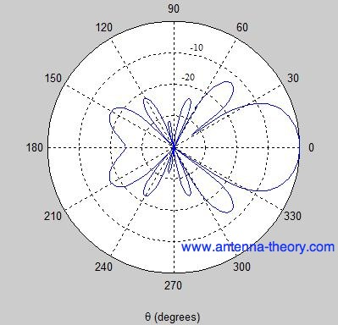

The Half-Power Beam width for helical antennas can be approximated (in degrees) by:

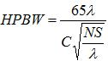

Helical antennas have found considerable use in space telemetry at the ground end of the link with ballistic missiles, satellites and space probes.

The circular polarisation in the helix is useful in space transmission since the ionosphere causes the waves to be rotationally polarised.